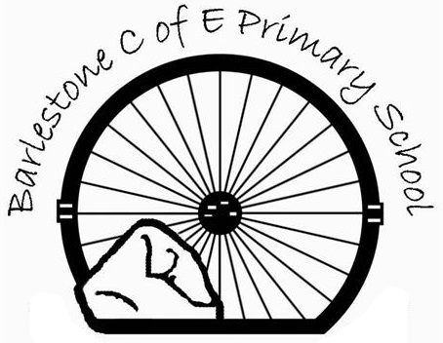
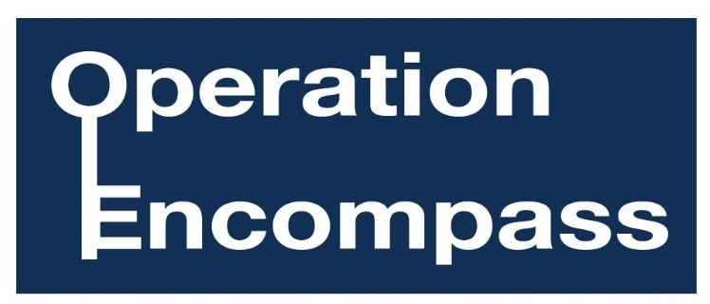
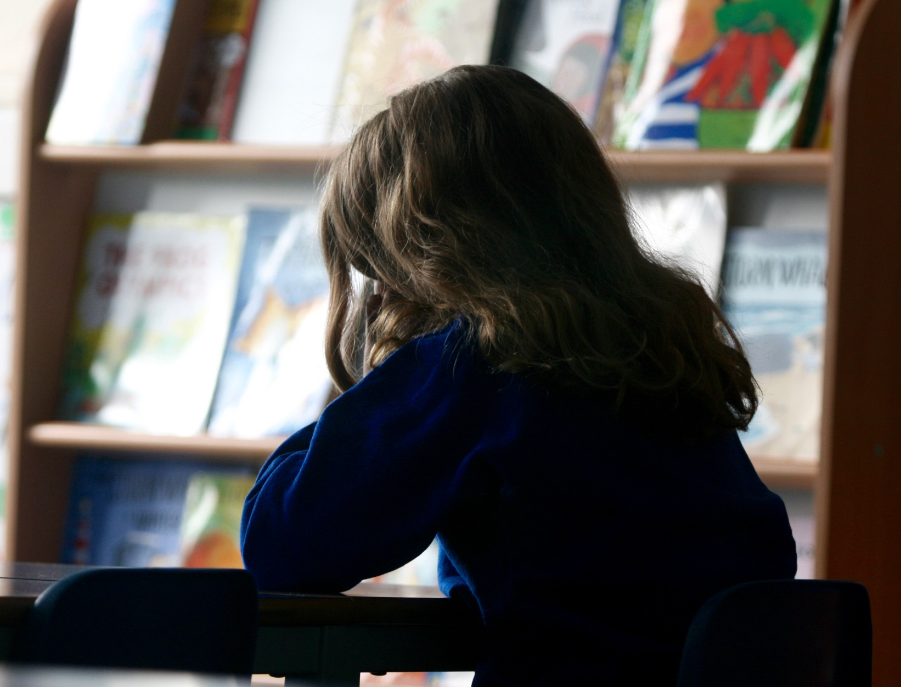
Photo posed by model
Supporting Children Exposed to Domestic Abuse
We are an Operation Encompass school.
For further information, please come in and see us, we’re always ready to listen.
Photo posed by models

