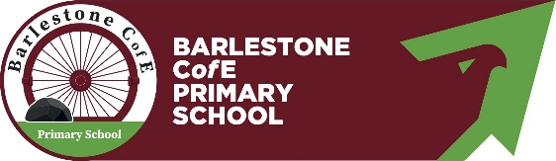
Barlestone C of E Primary School
Statutory Assessment information 2022-2023
EYFS pupils achieving a Good Level of Development
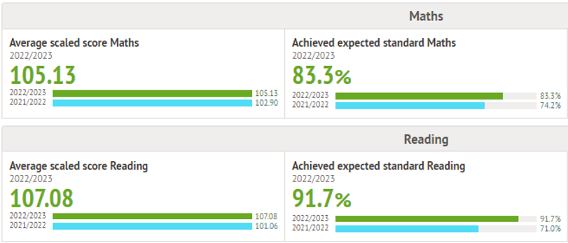
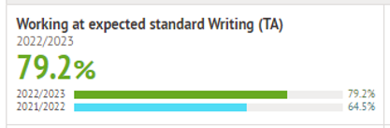
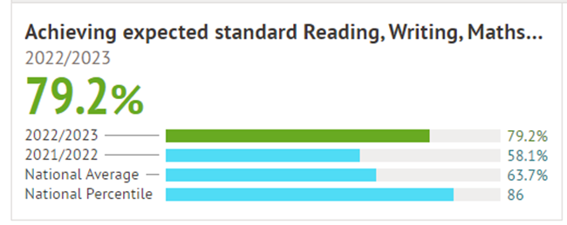
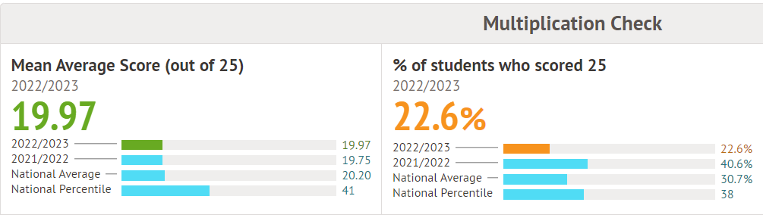
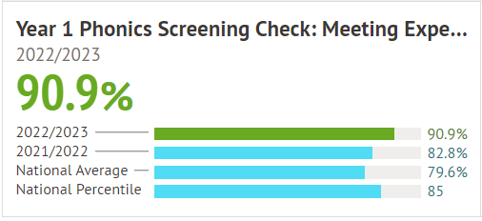
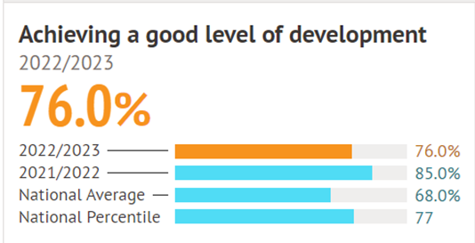
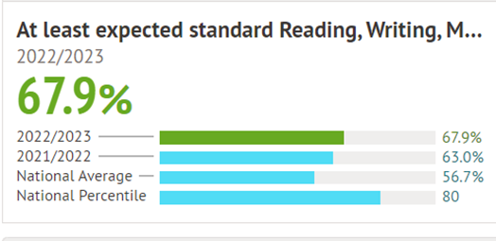
Predicted progress for Reading, Writing and Maths
Reading +1.67
Writing +1.13
Maths +0.93
Y6 pupils average scaled score and achieving expected standard in Maths and Reading
Y6 pupils achieving the expected standard in Writing
Y6 pupils achieving the expected standard in Reading, Writing and Maths combined
Y4 pupils average score for the times table check and % achieving full marks
Year 2 pupils achieving the expected standard in Reading, Writing and Maths combined
Y1 pupils passing the Phonics Screening Check

